**Soal**

*Case*

**My Product**

* The program consists of **5 menus**:

**1**. **Insert New product**

**2**. **Remove a product**

**3**. **See all product**

**4. Remove all product**

**5. Exit**

Figure 1. Main Menu

* If user chooses **Insert New Product** (**Menu 1**):
  + Ask user to input **product**’**s name**. Validate that the **name must be more than or equals two characters,** must **not contain white space (‘ ‘)** and must be **unique.**
  + The product’s **key should be the product’s name.**
  + Ask user to input **Product’s quality**. Validate that the **input must be either** “**super**”,“**good**”, **or** “**ok**” (**case insensitive**)
  + Input the **Product’s price**. Validate the price must **be divisible by 100**
  + Input product’s **stock**. Validate the month must be **between 1 and 100 inclusively**
  + Before inserting the data into the AVL Tree, **ask user for confirmation and show the product’s name**. if user input “**Y**” **then insert the product to the AVL Tree** and shows a **success message**. Otherwise, **redirect back** to the main menu

Figure 2. Insert product menu

* If user chooses **Remove a product** (**Menu 2**):
  + If the user does not have any **product**, **show a message** “**You don’t have any product!**”

Figure 3. No product message

* + Otherwise show the See all products view,and ask user to input product’s name
    - **Validate** if the inputted name does not exist, then **show a message** “**PRODUCT DOES NOT EXIST!**”
  + If the **inputted name is valid**, then **delete the product**’**s data** from the **AVL Tree**

Figure 4. Remove product

* If user chooses **See all products** (**Menu 3**):
  + If the user does not have any **product**, **show a message** “**You don’t have any product!**”

Figure 7. No product message

* + Otherwise, then **ask user how he wants to** display **the product’s** data

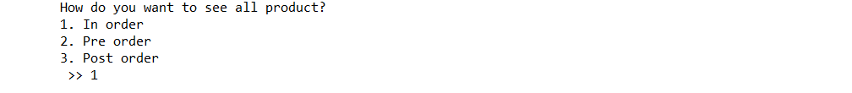

Figure 8. Ask user for display option

Figure 9. See product in in-order

Figure 10. Display product in pre-order

Figure 11. Display product in post-order

* If user chooses **Remove All** (**Menu 4**):
  + If the user does not have any product then **show a message** “**You don’t have any product!**”
  + Otherwise, before removing all the data, **ask user for confirmation**. **Validate** the input must be either “**Y**”or “**N**” (**case sensitive**)
  + If user choose “**Y**” then **remove all** the data from **AVL Tree** or else **redirect back** to main menu

Figure 12. No product message

Figure 13. Remove all product with confirmation

* If user chooses **Exit** (**Menu 5**) close the program.